Supplementary Materials
Title: Habitat coupling by small fish across lake-creek habitats: a missing link in freshwater food webs?
Authors: Charlotte A. Ward^{1,2}*, Reilly F. O’Connor¹, Timothy J. Fernandes^{1,2}, Kevin S. McCann^{1,2}, Mark S. Ridgway³, Bailey C. McMeans⁴, Tyler D. Tunney^{5,1}

Tables

Table S1. Examples of the use of lakes and adjacent creeks or streams by freshwater fishes.
Author & Year | Species | Trophic Level / Age Class | Direction of Movement | Hypothesized Driver
Brönmark et al. 2008 | Roach (Rutilus rutilus) | Primary consumer; Adult | Directional (lake→stream for overwintering, return to lake in spring) | Predator avoidance (reducing growth:predation trade-off in lake in winter)
Swanson et al. 2021 | White sucker (Catostomus commersonii); longnose sucker (Catostomus catostomus) | Secondary consumer; Adult | Directional (lake→stream for spawning, return to lake) | Reproduction (spawning); cued by water temperature, discharge, and time of day
Magnuson et al. 1985 | Multiple cyprinids and percids (8 species) | Primary–secondary consumer; YOY (and adult, treated separately) | Directional (lake→stream in fall/winter; stream→lake in spring) for YOY; within-lake vertical movements for adults | Hypoxia avoidance (winterkill avoidance); cued by ice formation or darkness (not oxygen stress itself)
Hahlbeck et al. 2022 | Redband rainbow trout (Oncorhynchus mykiss newberrii) | Tertiary consumer; Adult | Bidirectional (biannual: tributary↔lake) | Thermal refuge (summer) + foraging (spring/fall) + reproduction (winter spawning)
Colborne et al. 2019 | Lake sturgeon (Acipenser fulvescens) | Secondary consumer; Adult | Bidirectional (river↔lake; 5 distinct individual patterns) | Multiple: reproduction (spawning), foraging, and overwintering refuge; high individual variation
Jones et al. 2016 | Longnose sucker (Catostomus catostomus); white sucker (Catostomus commersonii) | Secondary consumer; Adult | Directional (lake→stream for spawning, return to lake) | Reproduction (spawning); nutrient subsidy transfer from lake to oligotrophic stream
He & Kitchell 1990 | Multiple small-bodied cyprinids (6+ species); northern pike (Esox lucius) as experimental predator | Primary consumer; Mixed (adults and juveniles) | Directional (lake→stream ; predation-driven emigration) | Predation avoidance (experimental); also hypoxia avoidance (seasonal)
Curry et al. 1997 | Brook trout (Salvelinus fontinalis) | Secondary consumer; Juvenile (YOY / age-0) | Directional (lake→stream during warmer periods, return to lake in cooler periods) | Thermal refuge (lake littoral temperatures approach lethal levels for YOY in summer; streams cold via groundwater)
Campbell et al. 2019 | Lahontan cutthroat trout (Oncorhynchus clarkii henshawi) | Tertiary consumer; age-0 and age-1+ juveniles | Directional (stream→lake for juveniles during spawning period of adults) | Seeking refuge from spawning adults and foraging opportunities in alternate lake habitat
Dolinsek et al. 2014 | 37 species (diverse community; Lake Ontario tributaries) | Primary–tertiary consumer; All age classes (adults and juveniles) | Bidirectional (lake↔stream) | Multiple: reproduction, foraging, predation refuge; not exclusively spawning — includes partial migration and non-reproductive habitat use
Bentley et al. 2015 | Arctic grayling (Thymallus arcticus); rainbow trout (Oncorhynchus mykiss) | Secondary consumer; Sub-adult | Bidirectional (inter-tributary movements using lake as corridor) | Foraging (prospecting for productive feeding patches; positioning for salmon subsidy)
Kikko et al. 2024 | Honmoroko (Gnathopogon caerulescens) | Primary consumer (planktivore); All age classes (juvenile through adult) | Directional (main lake → lagoons for spawning, with tributaries as corridors) | Reproduction (natal homing to spawning lagoon); foraging (availability of zooplankton prey)
Lindsey & Northcote 1963 | Redside shiner (Richardsonius balteatus) | Primary–secondary consumer; Adult and larvae/fry (treated separately) | Directional (lake→stream for spawning; fry passively downstream stream→lake) | Reproduction (spawning; triggered by temperature >10°C); passive fry displacement away from ephemeral stream habitat

Table S2. Mean (± SD) stable isotope values of δ¹³C and δ¹⁵N (‰) for all organisms sampled in creek and lake habitats across three seasons (Spring, Summer, Fall).
Organism | Location | Month | n | Mean_d13C | SD_d13C | Mean_d15N | SD_d15N
Mayfly | Creek | Spring | 10 | -32.48 | 2.21 | 2.81 | 1.04
 |  | Summer | 10 | -33.55 | 1.66 | 2.4 | 0.42
 |  | Fall | 5 | -31.79 | 0.17 | 3.51 | 0.11
 | Lake | Spring | 23 | -26.38 | 2.49 | 1.85 | 0.81
 |  | Summer | 27 | -24.32 | 2.73 | 0.82 | 0.58
 |  | Fall | 4 | -26.16 | 0.72 | 1.22 | 0.2
Mussel | Creek | Spring | 10 | -30.68 | 0.54 | 4.07 | 0.26
 |  | Summer | 8 | -30.62 | 1.04 | 4.15 | 1.07
 |  | Fall | 3 | -30.83 | 0.59 | 4.43 | 0.84
 | Lake | Spring | 17 | -28.84 | 1.93 | 1.37 | 0.89
 |  | Summer | 22 | -27.76 | 1.52 | 0.83 | 0.71
 |  | Fall | 13 | -28.32 | 0.32 | 1.35 | 0.61
Common shiner | Creek | Spring | 37 | -29.14 | 1.6 | 5.3 | 0.62
 |  | Summer | 15 | -30.11 | 1.3 | 5.5 | 0.77
 |  | Fall | 37 | -28.6 | 1.43 | 5.57 | 0.67
 | Lake | Spring | 22 | -28.51 | 2 | 5.39 | 0.57
 |  | Summer | 1 | -23.01 | NA | 3.8 | NA
 |  | Fall | 5 | -25.3 | 0.86 | 5.55 | 0.32
Golden shiner | Creek | Spring | 40 | -29.07 | 1.23 | 5.72 | 0.78
 |  | Summer | 20 | -30.41 | 1.05 | 5.63 | 0.51
 |  | Fall | 28 | -29.86 | 1.38 | 5.62 | 0.74
 | Lake | Spring | 27 | -28.41 | 0.81 | 5.55 | 0.65
 |  | Summer | 2 | -26.5 | 0.87 | 4.85 | 0.14
 |  | Fall | 18 | -26.67 | 2.01 | 5.07 | 0.88

Table S3. Results of generalized linear models (GLMs) testing the effects of season, release location, and their interaction on stable isotope values (δ¹³C and δ¹⁵N) of mayflies and mussel samples. Chi-squared statistics and p-values are from Type II or Type III likelihood ratio tests.
Variable | Factor | Chi Squared | df | p-value | Model type
Mayfly δ¹³C | Season | 0.682444 | 2 | 7.11E-01 | Gaussian GLM - Type III
 | Release location | 109.7741 | 1 | 1.10E-25
 | Season:release location | 7.894751 | 2 | 1.93E-02
Mayfly δ¹⁵N | Season | 18.21115 | 2 | 1.11E-04 | Gaussian GLM - Type III
 | Release location | 67.65177 | 1 | 1.95E-16
 | Season:release location | 7.212057 | 2 | 2.72E-02
Mussel δ¹³C | Season | 24.11066 | 2 | 5.81E-06 | Gaussian GLM - Type II
 | Release location | 42.41295 | 1 | 7.39E-11
Mussel δ¹⁵N | Season | 29.14971 | 2 | 4.68E-07 | Gaussian GLM - Type II
 | Release location | 303.6874 | 1 | 5.18E-68

Model | Formula | Df | Loglik | AIC | BIC
gamm_3 | multiple_locations ~ s(day_of_year, bs = "cc") + s(tl) + release_location | 7 | -4217.75 | 8449.508 | 8487.431
gamm_1 | multiple_locations ~ s(day_of_year, bs = "cc") + s(tl) + release_location | 6 | -4246.72 | 8505.439 | 8537.944
gamm_0 | multiple_locations ~ s(day_of_year, bs = "cc") + s(tl) + release_location | 5 | -4366.85 | 8743.702 | 8770.79
gamm_2 | multiple_locations ~ s(day_of_year, bs = "cc") + s(tl) + release_location | 6 | -4417.36 | 8846.723 | 8879.228

Table S4. Results of generalized linear models (GLMs) testing the effects of season, location of capture/release, and their interaction on shiner coupling metrics (foraging, movement, and biomass) and the size of shiners and smallmouth bass captured within lake and creek habitats. Chi-squared statistics and p-values are from Type II or Type III likelihood ratio tests.
Variable | Factor | Chi Squared | df | p-value | Model type
Prop. lake carbon | Season | 37.80335 | 2 | 6.18E-09 | Binomial GLM - Type III
 | Location | 64.76723 | 1 | 8.43E-16
 | Season:location | 49.03206 | 2 | 2.25E-11
Trophic position | Season | 13.80686 | 2 | 1.00E-03 | Gaussian GLM -Type III
 | Location | 40.58478 | 1 | 1.88E-10
 | Season:location | 25.36142 | 2 | 3.11E-06
Recurrence | Season | 32.67014 | 2 | 8.05E-08 | Negative binomial GLM - Type II
 | Release_location | 11.01503 | 1 | 9.04E-04
Residency | Season | 4.085497 | 2 | 0.129672 | Binomial GLM - Type II
 | Release_location | 9.227021 | 1 | 0.002385
Directional trap biomass | Season | 29.97675 | 2 | 3.09E-07 | Gaussian GLM -  type III
 | Direction | 0.536987 | 1 | 4.64E-01
 | Season:direction | 16.3676 | 2 | 2.79E-04
Minnow trap biomass | Season | 9.234694 | 2 | 9.88E-03 | Tweedie GLM with log link -type III
 | Location | 9.851438 | 1 | 1.70E-03
 | Season:Location | 9.039771 | 2 | 1.09E-02
Shiner total length | Season | 1.186125 | 2 | 5.53E-01 | Gaussian GLM - type III
 | Location | 153.4348 | 1 | 3.08E-35
 | Season:location | 30.81639 | 2 | 2.03E-07
SMB total length | Season | 5.629744 | 2 | 5.23E-02 | Tweedie GLM with log link - type III
 | Location | 124.9957 | 1 | 4.43E-25

Model | Formula | K | logLik | AIC | ΔAIC | Weight
gamm_3c | multiple_locations ~ s(day_of_year, bs = "cc") + release_location | 5 | -4217.55 | 8445.103 | 0 | 0.564
gamm_3d | multiple_locations ~ s(day_of_year, bs = "cc") | 4 | -4219.57 | 8447.134 | 2.032 | 0.204
gamm_3b | multiple_locations ~ s(day_of_year, bs = "cc") + tl + release_location | 6 | -4217.75 | 8447.504 | 2.402 | 0.17
gamm_3a | multiple_locations ~ s(day_of_year, bs = "cc") + s(tl) + release_location | 7 | -4217.75 | 8449.508 | 4.406 | 0.062

model | formula | df | logLik | AIC | BIC | n
gamm_3 | multiple_locations ~ s(day_of_year, bs = "cc") + s(tl) + release_location | 7 | -4217.75 | 8449.508 | 8487.431 | 1665
gamm_1 | multiple_locations ~ s(day_of_year, bs = "cc") + s(tl) + release_location | 6 | -4246.72 | 8505.439 | 8537.944 | 1665
gamm_0 | multiple_locations ~ s(day_of_year, bs = "cc") + s(tl) + release_location | 5 | -4366.85 | 8743.702 | 8770.79 | 1665
gamm_2 | multiple_locations ~ s(day_of_year, bs = "cc") + s(tl) + release_location | 6 | -4417.36 | 8846.723 | 8879.228 | 1665

Figures
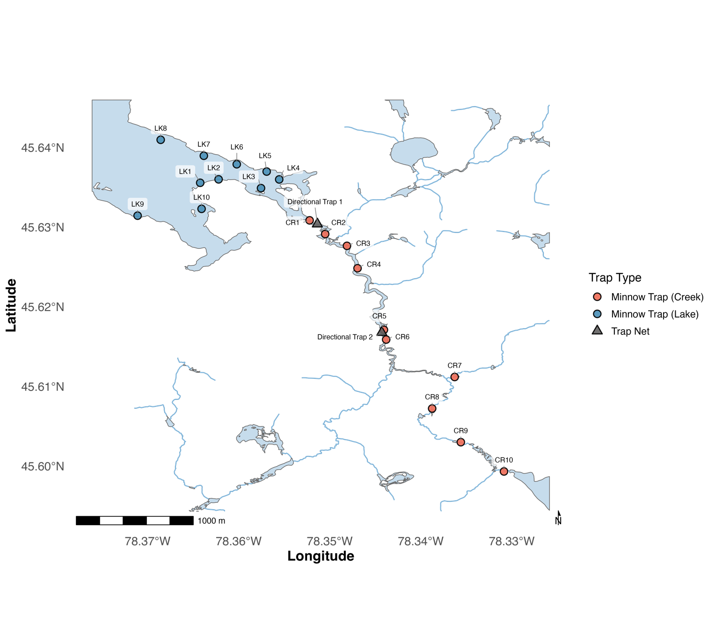
Figure S1. Locations of minnow traps (pink and blue circles) and directional trap nets (grey triangles) within the study system. Ten minnow traps were deployed throughout each habitat (lake and creek) during each sampling season. Directional trap nets were positioned at the mouth of Costello Creek (Directional Trap 1) and approximately two kilometers upstream (Directional Trap 2) to capture fish moving directionally between habitats.

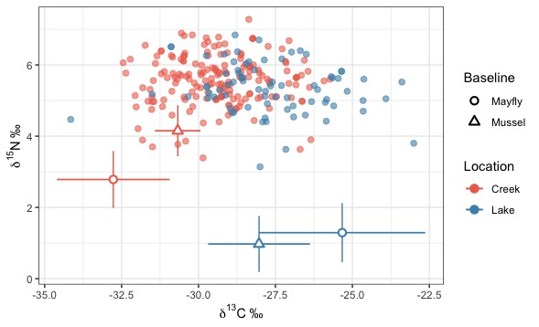

Figure S2. Biplot of δ¹³C and δ¹⁵N stable isotope values from shiner liver tissue (n = 252). Each point represents an individual shiner liver sample, coloured by the location in which the fish was captured (lake = blue, creek = pink). Baseline values are shown as mean ± SD for mayflies and mussels collected in each habitat across the study period.

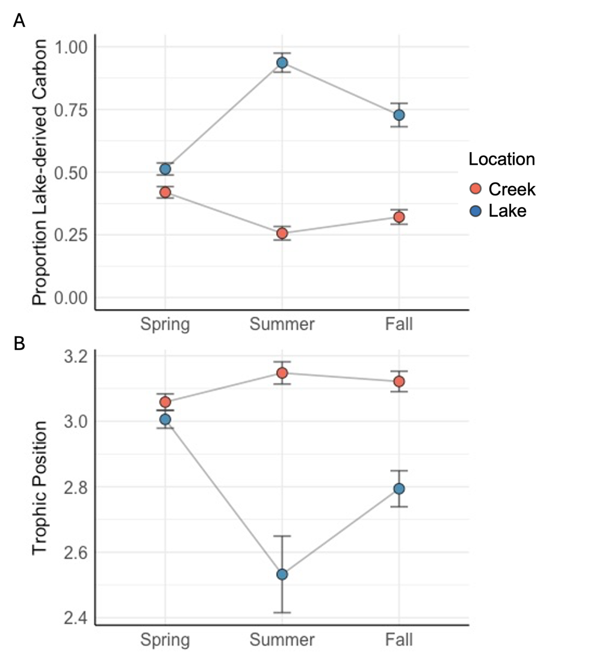

Figure S3. Mean (±SE) proportion of lake-derived carbon (A) and trophic position (B) of fish captured in the creek (pink) and lake (blue) across seasons calculated from non-lipid corrected stable isotope data.
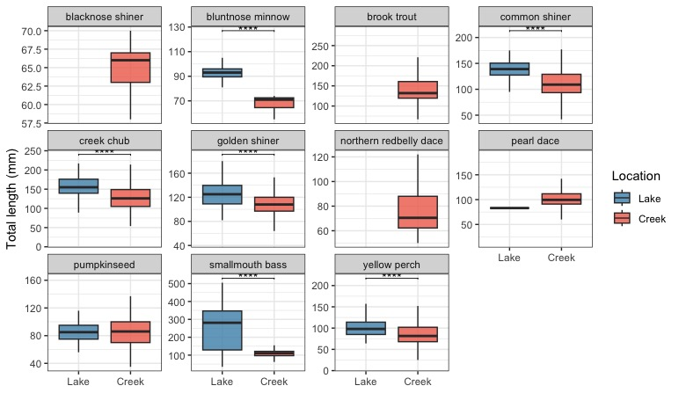

Figure S4. Boxplots of total length (mm) for fish species captured in lake (blue) and creek (pink) during seasonal netting surveys and angling across the study period. Each panel shows a different species. Asterisks denote significant differences in total length between habitats (*p < 0.05, **p < 0.01, ***p < 0.001, ****p < 0.0001).

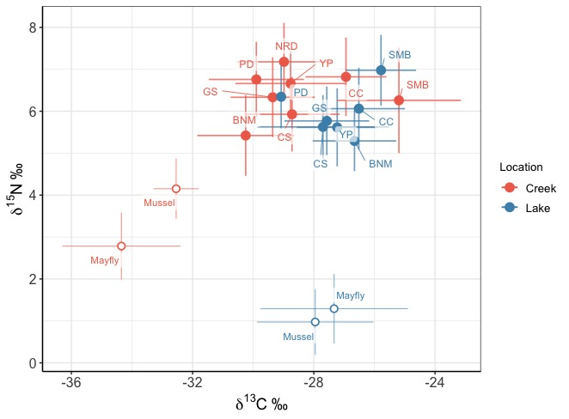

Figure S5. Biplot of mean (± SD) δ¹³C and δ¹⁵N stable isotope values from liver tissues of fish species captured in lake (orange) and creek (blue) habitats. Points represent species means, labelled with species abbreviations (BNM = bluntnose minnow, CC = creek chub, CS = common shiner, GS = golden shiner, NRD = northern redbelly dace, PD = pearl dace, SMB = smallmouth bass, YP = yellow perch). Baseline values are shown for mayflies and mussels collected in each habitat.

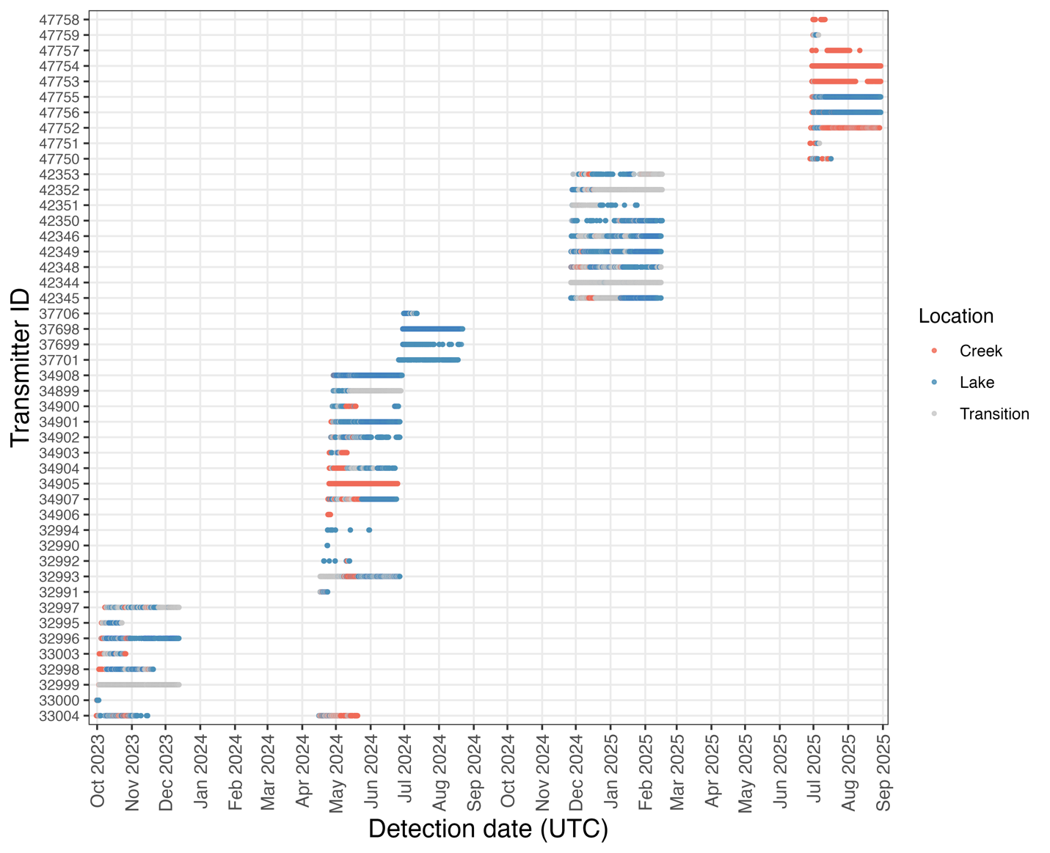
Figure S6. Abacus plot of acoustic telemetry detections for tagged golden shiners from October 2023 to September 2025. Each row represents an individual fish (identified by transmitter ID), with points showing detections over time. Colours indicate the location (habitat) the fish was in at the time of detection (creek = pink, lake = blue, transition = grey).
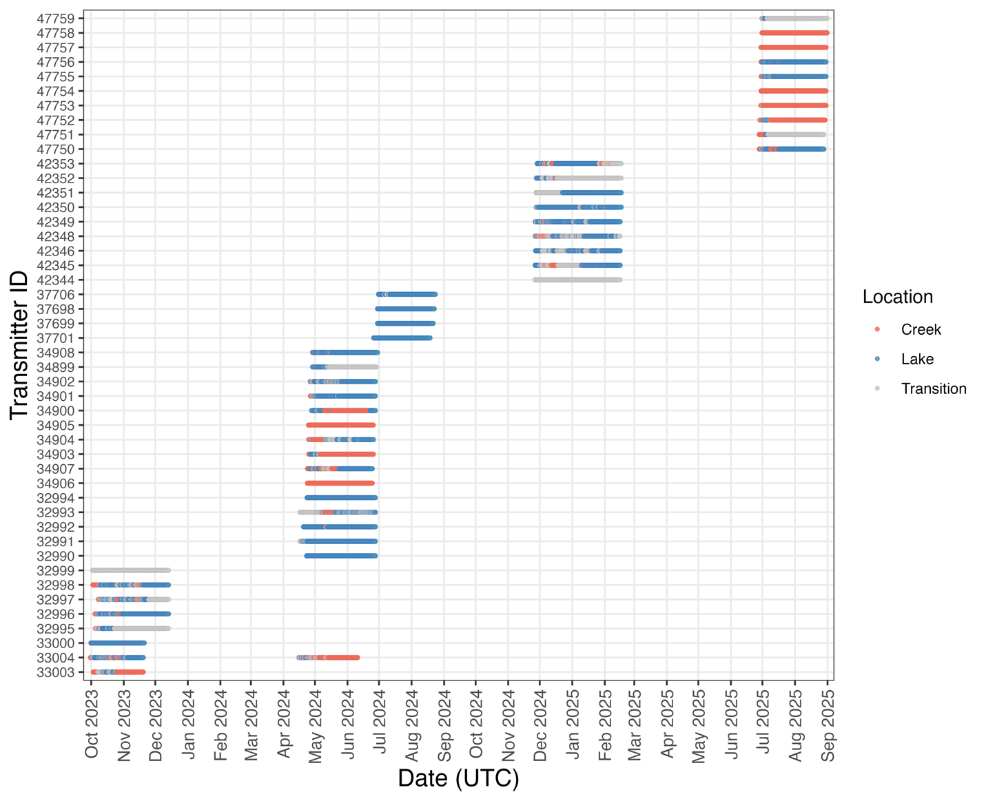
Figure S7. Abacus plot of enriched acoustic telemetry dataset for tagged shiners from October 2023 to September 2025. Each row represents an individual fish (identified by transmitter ID), with horizontal bars showing continuous periods where the last known location was carried forward in the absence of detections within a given minute. Colours indicate the location (habitat) the fish was in at the time of detection (creek = pink, lake = blue, transition = grey).

